Crop Prediction
Project report submitted in partial fulfillment of the requirements for the award of the Masters Degree
By
SivaKumar Vunnam
Under the Esteemed Guidance of
Robert Marceau
Email: rmarceau@rivier.edu

ABSTRACT
The main objective of this project is to predict the crop and maintain the crop. Usually farmers declare several months as Crop Holiday due to lack of water content and knowledge on other crops, and simply losing the yield. Traditional farming techniques and crops to be selected are inherited from the fore fathers. In the olden days, this helped farmers a lot, but, as the conditions change day by day very rapidly, farmers are forced to cultivate more and more crops. Being this as the current situation, many of them don’t have enough knowledge about the new crops and are not completely aware of the benefits they get while farming them.
The proposed system is that to give necessary suggestions to farmers to grow more than a crop in a year by giving suggestions about other crops which are suitable for their land conditions in their area. It will help farmers from Indian villages to grow more than a crop in year and attain self sustainability, to increase the fertility of the soil and to learn the features and techniques of other crops and their possibility. The modules of the system are soil selection in which the soil of the particular area is determined and selected, season selection in which the season that is required for the suggestions, crop selection in which the crops are listed out based upon the soil and the season selected before and a suitable crop is selected, maintenance in which the steps that are necessary to maintain the crop efficiently are described in brief. The scope of the system is that it can be extended further to give necessary information and alerts to farmers about the crops that they are growing.

LIST OF FIGURES
FIGURE NO DESCRIPTION PAGE NO
- Fig 2.1 Java Virtual Machine 11
- Fig 2.2 API of Java Platform 12
- Fig 2.3 An Overview of the Software Development Process 12
- Fig 4.1 Use Case Diagram 20
- Fig 4.2 Class Diagram 21
- Fig 4.3 Sequence Diagram 22
- Fig 4.4 Collaboration Diagram 23
- Fig 4.5 State Diagram 24
- Fig 4.6 Activity Diagram 25
- Fig 4.7 Component Diagram 26

LIST OF TABLES
TABLE NO DESCRIPTION PAGE NO
- Table 6.1 Data Base of Jonna 48
- Table 6.2 Data Base of Sajja 48

LIST OF OUTPUT SCREENS
SCREEN NO DESCRIPTION PAGE NO
- Screen 8.1 Running the Project 55
- Screen 8.2 Load Database File 55
- Screen 8.3 Main Screen 56
- Screen 8.4 Select Soil 56
- Screen 8.5 Select Crop 56
- Screen 8.6 Select Crop Type 57
- Screen 8.7 Select Season 57
- Screen 8.8 Select Crop 57
- Screen 8.9 Select Crop Type 58
- Screen 8.10 Select Crop 58
- Screen 8.11 Select Crop Type 58
- Screen 8.12 Report on selected Crop 59
- Screen 8.13 Characteristics of selected Crop 59

TABLE OF CONTENTS
TITTLE PAGE NO
LIST OF FIGURES 3
LIST OF TABLES 3
LIST OF OUTPUT SCREENS 4
- INTRODUCTION 5
  - Scope of the Project 7
  - Vision of the Project 7
  - Existing System 7
  - Limitations in Existing System 8
  - Proposed System 8
  - Advantages of Proposed System 8
- LITERATURE SURVEY 9
  - Java Technology 9
    - Concepts Used 9
    - The Java Platform 10
      - Java Virtual Machine 11
      - Java API 14
    - Java Code Execution 15
  - Microsoft Access 16
- SOFTWARE REQUIREMENT ANALYSIS 19
  - Problem Definition 19
  - Functional Modules 19
    - Soil Selection Module 19
    - Season Selection Module 19
    - Crop Selection Module 19
- SOFTWARE DESIGN 20
  - UML Diagram 20
    - Use Case Diagram 20
    - Class Diagram 21
    - Sequence Diagram 22
    - Collaboration Diagram 23
    - State Diagram 24
    - Activity Diagram 25
    - Component Diagram 26
- SOFTWARE AND HARDWARE REQUIREMENTS 28
  - Software Requirements 28
  - Hardware Requirements 28
- CODING 29
  - Locating Database 29
  - Connecting to Database 31
  - Generating Report 32
  - Database Tables 47
- TESTING 49
  - Testing Approach 49
  - Test Strategies 49
  - Test Cases 49
- OUTPUT SCREENS 52
  - Snapshots 53
- CONCLUSION 57
- FURTHER WORKS 58
- BIBLIOGRAPHY 59

- INTRODUCTION
Information Technology (IT) has brought revolutionary changes in the world and has a great impact on the way we live and work. The development of high-end technologies such as telecommunications, computing and the Internet has made life so simple and easy that any kind of information can be found using Computers.
The IT industry is growing exponentially all over the world including India. The IT industry has spread over many fields including Agriculture. It has been used for various purposes such as recording timely data of crop farming, research, and information repository.
The Crop Prediction is an information providing application which contains data regarding various crops that can be cultivated. The application is supported by a database consisting of the details of the crops. We can add more crops to the database.
  - Scope of the Project
The objective of the Crop Prediction system is to provide necessary information regarding the crops that can be cultivated in a particular region. This is a new concept as the traditional information is only printed on paper and not in electronic format.
This system is a computerized form of the critical data and information regarding the crops and helps farmers by facilitating ease of gaining knowledge on the crops, both old and new. More functionality can be added to this system.
  - Vision of the Project
The vision of the Crop Prediction system is to provide necessary information required for farmers, any agricultural agencies for seeking information regarding crops that can be cultivated in a particular region.
  - Existing System
In India, there are three crop seasons and one season as a Crop Holiday. Crops are cultivated during these three seasons and the land is left alone during the Crop Holiday without any usage. Usually, farmers declare several months as Crop Holiday due to lack of water content and knowledge on other crops, and simply losing the yield.
  - Limitations in Existing System
Traditional farming techniques and crops to be selected are inherited from the fore fathers. In the olden days, this helped farmers a lot, but, as the conditions change day by day very rapidly, farmers are forced to cultivate more and more crops. Being this as the current situation, many of them don’t have enough knowledge about the new crops and are not completely aware of the benefits they get while farming them.
  - Proposed System
The project aims to implement an application that helps farmers to gain knowledge of the new crops that can be cultivated in their region thereby eliminating the idle time during Crop Holidays.
  - Advantages of Proposed System
It will help farmers from Indian villages to grow more than a crop in year and attain self sustainability, to increase the fertility of the soil and to learn the features and techniques of other crops and their possibility.

- LITERATURE SURVEY
The technologies used for development of this project are:
Java
Microsoft Access
  - Java Technology
Java technology is both a programming language and a platform. It is a general purpose, concurrent, class-based, object oriented language. Java is currently one of the most popular programming languages in use.
    - Concepts Used
Java is used as the Front-end for the project. It is used to connect to the database by its API. The concepts used in the project are as described below.
JDBC-ODBC Bridge: A JDBC driver is a software component enabling a Java application to interact with a database. To connect with individual databases, JDBC (the Java Database Connectivity API) requires drivers for each database. The JDBC driver gives out the connection to the database and implements the protocol for transferring the query and result between client and database.
The JDBC type 1 driver, also known as the JDBC-ODBC Bridge, is a database driver implementation that employs the ODBC driver to connect to the database. The driver converts JDBC method calls into ODBC function calls. It translates a query by JDBC into corresponding ODBC query, which is then handled by ODBC Driver.
The coding template used for implementation of JDBC-ODBC Bridge is as follows:

String database="jdbc:odbc:Driver={Microsoft Access Driver (*.mdb, *.accdb)};DBQ="+file+";";
try {
Class.forName("sun.jdbc.odbc.JdbcOdbcDriver");
con=DriverManager.getConnection(database,"","");
stmt=con.createStatement();
}

catch (Exception e) {
e.printStackTrace();
}

- JFrame
A Frame is a top-level window with a title and a border. The size of the frame includes any area designated for the border. The dimensions of the border area may be obtained using the getInsets method, however, since these dimensions are platform-dependent, a valid insets value cannot be obtained until the frame is made displayable by either calling pack or show. Since the border area is included in the overall size of the frame, the border effectively obscures a portion of the frame, constraining the area available for rendering and/or displaying subcomponents to the rectangle which has an upper-left corner location of (insets.left, insets.top), and has a size of width - (insets.left + insets.right) by height - (insets.top + insets.bottom). The default layout for a frame is BorderLayout.
An extended version of java.awt.Frame that adds support for the JFC/Swing component architecture.
The coding template used for the implementation of JFrame is as follows:

JFrame f1=new JFrame();
f1.setTitle("Crops Information");
f1.setVisible(true);
f1.addWindowListener(this);
f1.setLayout(new BorderLayout(20,20));

- JPanel
JPanel is a public java swing class which is used to create a general-purpose container JPanel objects that are used to group other GUI components without adding any functionality to the added components.
JPanel panel objects can add color to their background and also can be customized. JPanel inherits methods from its super classes namely JComponent, Container, and Component java classes. JPanel is an extension of java swing JComponent class. JPanel class implements Accessible interface.
The coding template used for the implementation of JPanel is as follows:

JPanel p1=new JPanel(g);
f1.add(p1,"West"); p1.add(l1,c);

- JButton
It is an implementation of a "push" button. Buttons can be configured, and to some degree controlled, by Actions. Using an Action with a button has many benefits beyond directly configuring a button.
The coding template used for implementing JButton is as follows:

JButton b1=new JButton("Generate Report");
p3.add(b1,BorderLayout.SOUTH);
b1.setFocusable(false);
b1.addActionListener(this);

- Action Listener
It is the listener interface for receiving action events. The class that is interested in processing an action event implements this interface, and the object created with that class is registered with a component, using the component's addActionListener method. When the action event occurs, that object's action Performed method is invoked.
The coding template used for implementing Action Listener is as follows:

public class GUI implements ActionListener, WindowListener{
// code
b1.addActionListener(this);
//code
}
public void actionPerformed(ActionEvent e){
JButton source = (JButton) e.getSource();
if(source==b1)
//code
}

- Result Set
It is a table of data representing a database result set, which is usually generated by executing a statement that queries the database. A Result Set object maintains a cursor pointing to its current row of data. Initially the cursor is positioned before the first row. The next method moves the cursor to the next row, and because it returns false when there are no more rows in the Result Set object, it can be used in a while loop to iterate through the result set.
A default Result Set object is not updatable and has a cursor that moves forward only. Thus, you can iterate through it only once and only from the first row to the last row. It is possible to produce Result Set objects that are scrollable and/or updatable. The following code fragment, in which con is a valid Connection object, illustrates how to make a result set that is scrollable and insensitive to updates by others, and that is updatable.
The coding template used for the implementation of Result Set is as follows:

public Result Set display(Connection con, Statement stmt, Result Set rs, String text){
try {
out.println(text);
rs=stmt.executeQuery("select * from Data where Crop='"+text+"'");
rsmd=rs.getMetaData();
columnCount=rsmd.getColumnCount();
for(i=1;i<columnCount+1;i++)
columnName.add(rsmd.getColumnLabel(i));
return rs;
} catch (Exception e) {
e.printStackTrace();
}
return null;
}

    - The Java Platform
A platform is the hardware or software environment in which a program runs. The Java platform differs from most other platforms in that it's a software-only platform that runs on top of other hardware-based platforms.
The Java platform has two components:
- The Java Virtual Machine
- The Java Application Programming Interface (API)
      - Java Virtual Machine
Java Virtual Machine is the base for the Java platform and is ported onto various hardware-based platforms. The terms "Java Virtual Machine" and "JVM" mean a Virtual Machine for the Java platform.
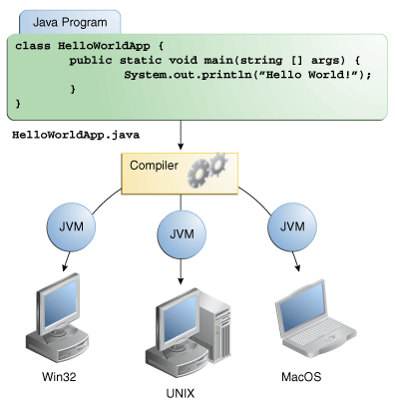
Fig 2.1 Java Virtual Machine
Through the Java VM, the same application is capable of running on multiple platforms.
      - Java API
The Java API is a large collection of ready-made software components that provide many useful capabilities. It is grouped into libraries of related classes and interfaces; these libraries are known as packages.
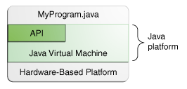
Fig 2.2 API of Java Platform
    - Java Code Execution
In the Java programming language, all source code is first written in plain text files ending with the .java extension. Those source files are then compiled into .class files by the javac compiler. A .class file does not contain code that is native to your processor; it instead contains byte codes — the machine language of the Java Virtual Machine (Java VM). The java launcher tool then runs your application with an instance of the Java Virtual Machine.
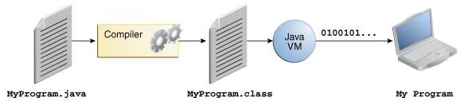
Fig 2.3 an overview of the Software Development Process.

  - Microsoft Access
Microsoft Access is a database management system from Microsoft that combines the relational Microsoft Jet Database Engine with a graphical user interface and software-development tools. MS Access stores data in its own format based on the Access Jet Database Engine. It can also import or link directly to data stored in other applications and databases. In addition to using its own database storage file, Microsoft Access may also be used as the 'front-end' with other products as the 'back-end' tables, such as Microsoft SQL Server.
This project uses the Microsoft Access as the ‘back-end’ database. The tabular data is retrieved using the basic SQL commands. The SQL commands used in this project are as described below.
- Database Schema
One database is used in this application. It is used for storing the information regarding crops.
Data table consists of the following schema

Data (id , Type, Season, Duration, Yield, Soil, Characteristics)

id is the primary key and the other fields consists of the data regarding various unique crops.
- CREATE
First of all we need to create a database. Our database name is MPProject1. SQL Command is as follows

Con=DriverManager.getConnection (database,"","");
This command returns a connection with the specified Database. Now create database of crops.

rs=stmt.executeQuery(“create table Data(id number primary key, Type text, Season text, Duration text, Yield Text, Soil text, Characteristics text);”);
- INSERT
After creating database insert the values into the database. Insert all the records into the database.

rs=stmt.executeQuery(“insert into Data values(‘1’,’ Bapatla Sannalu’,’ Kharif’,’165’, ’2.5’,’Clay Soil’,’’);”);
- SELECT
If we want to select all the rows from faculty table, then query is as follows

rs=stmt.executeQuery(“select * from Data where Crop=’Rice’;”);
Cursor is like a pointer that points to each row of the resulted query.

- SOFTWAWRE REQUIREMENT ANALYSIS
  - Problem Definition
In this project, data plays an important role. But the required data is not readily available for usage. The data regarding the required crops are to be collected from various resources of Agricultural Department, Agricultural College and Farmers. Moreover, the data will be in Telugu and hence is to be translated into English before it is used in the Project.
  - Functional Modules
Application contains following modules
  - Soil Selection module
  - Season Selection module
  - Crop Selection module
    - Soil Selection Module
The purpose of this module is to provide information regarding crops based upon the soils. When the user selects a particular soil, then he would get information regarding all the crops that are available and can be cultivated in that particular kind of soil.

    - Season Selection Module
The purpose of this module is to provide information regarding crops based upon the seasons. When the user selects the particular season, then he would get information regarding all the crops that are available and can be cultivated in that particular area in the selected season.

    - Crop Selection Module
The purpose of this module is to provide information regarding the crop that the user has selected. This is an independent module and would give a better result if combined used with the first two modules.
- SOFTWARE DESIGN
Software design is a process of problem solving and planning for a software solution. After the purpose and specifications of software are determined, a plan for a solution is developed. It includes low-level component and algorithm implementation issues as well as the architectural view.
  - UML Diagram
The Unified Modeling Language (UML) is a language for specifying, constructing, visualizing, and documenting the artifacts of a software-intensive system. Analogous to the use of architectural blueprints in the construction industry, UML provides a common language for describing software models, and it can be used in conjunction with a wide range of software lifecycles and development processes.
    - Use Case Diagram
Use Case diagrams identify the functionality provided by the system (use cases), the users who interact with the system (actors), and the association between the users and the functionality. Use Cases are used in the Analysis phase of software development to articulate the high-level requirements of the system.
The primary goals of Use Case diagrams include:
- Providing a high-level view of what the system does
- Identifying the users ("actors") of the system
- Determining areas needing human-computer interfaces
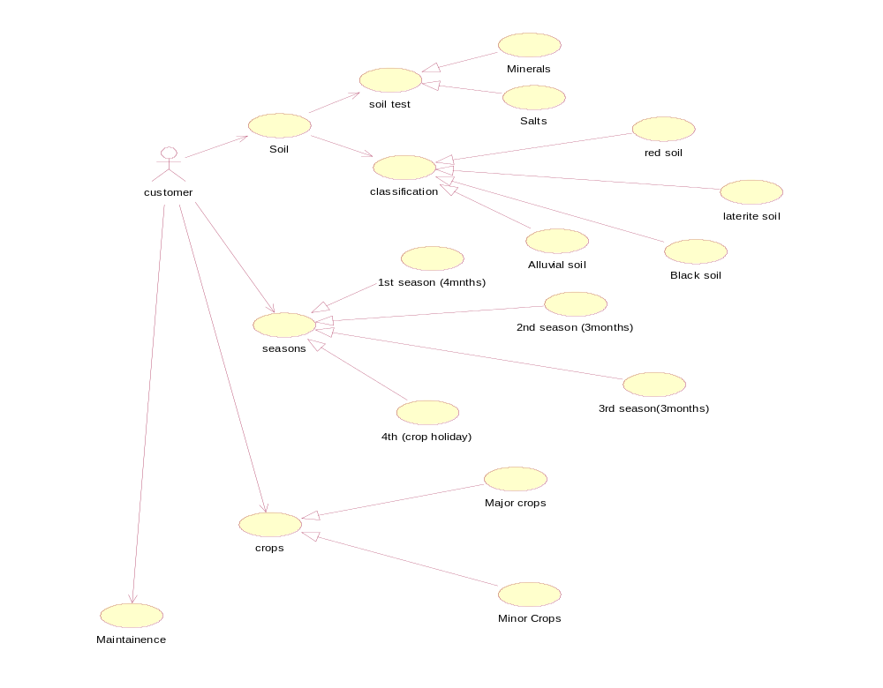
Fig 4.1 Use Case Diagram
    - Class Diagram
Class diagram are used to describe the type of objects and their relationship by providing a static, structural view of a system. Class diagrams show the classes of the system, their interrelationships (including inheritance, aggregation, and association), and the operations and attributes of the classes. Class diagrams are used for a wide variety of purposes, including both conceptual/domain modeling and detailed design modeling.
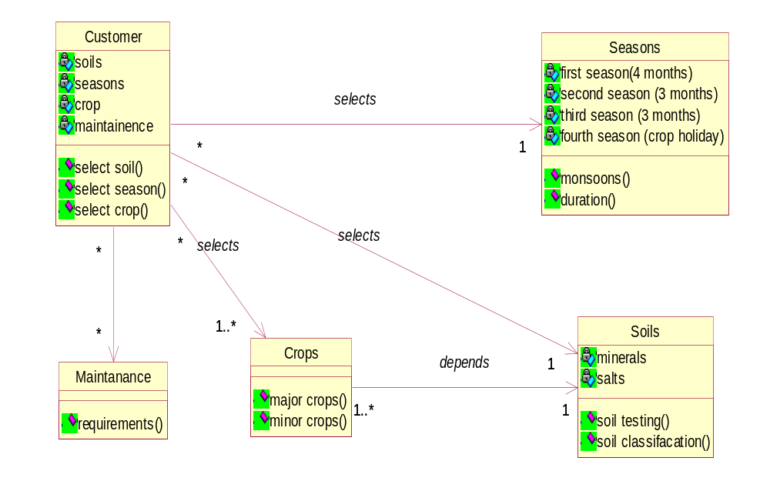
Fig 4.2 Class Diagram
    - Sequence Diagram
Sequence diagrams document the interactions between classes to achieve a result, such as a use case. Because UML is designed for object-oriented programming, these communications between classes are known as messages. The Sequence diagram lists objects horizontally, and time vertically, and models these messages over time.
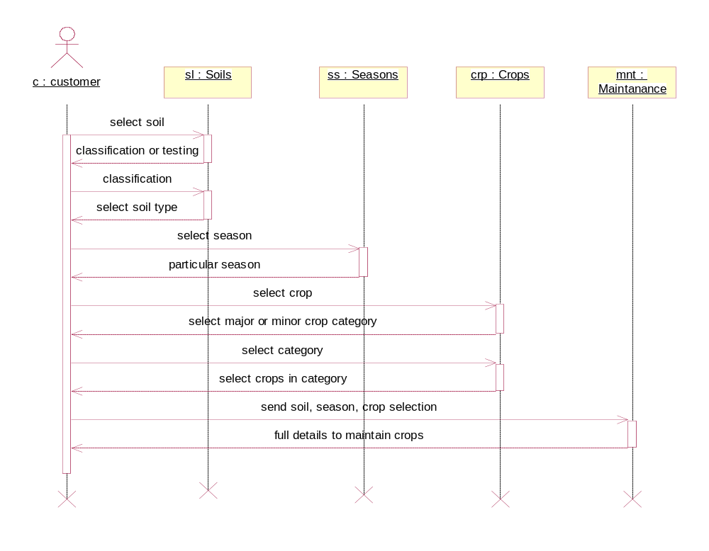
Fig 4.3 Sequence Diagram
    - Collaboration Diagram
A collaboration diagram is an interaction diagram that emphasizes the structural organization of the objects that send and receive messages. It is crossed between a symbol diagram and sequence diagram. The numbered arrows show the movement of messages.
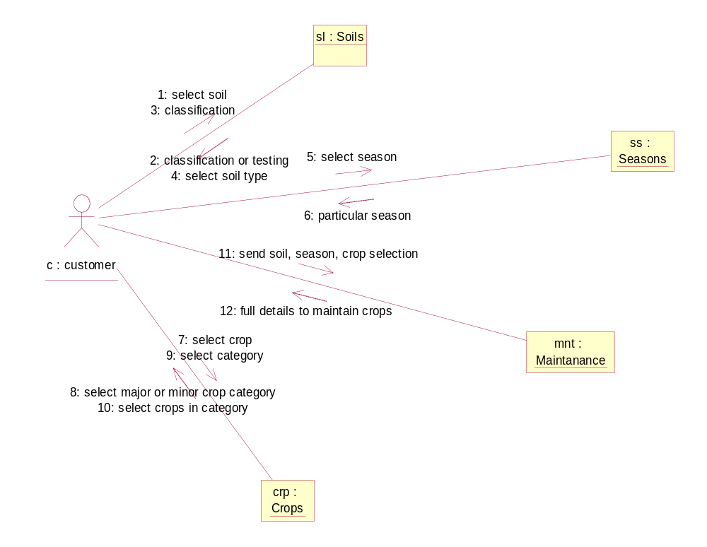
Fig 4.4 Collaboration Diagram
    - State Diagram
The State chart diagram describes the behavior of a single object class, especially if the classes illustrate significant dynamic behavior. State chart / state transition diagram for those types of classes. It shows the a life history of a given class, the events that causes a transition from one state to another, and the action that results from a state change.
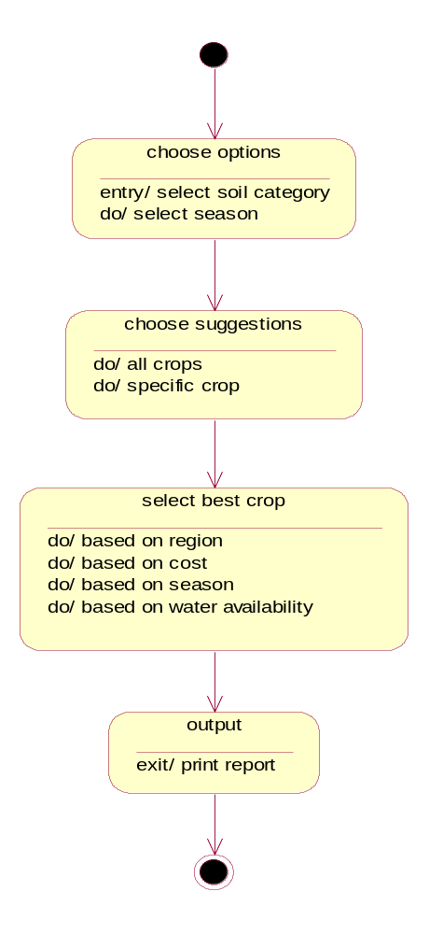
Fig 4.5 State Diagram
    - Activity Diagram
Activity diagrams are used to document workflows in a system, from the business level down to the operational level. In fact, the Activity diagram is a variation of the state diagram where the "states" represent operations, and the transitions represent the activities that happen when the operation is complete. The general purpose of Activity diagrams is to focus on flows driven by internal processing vs. external events.
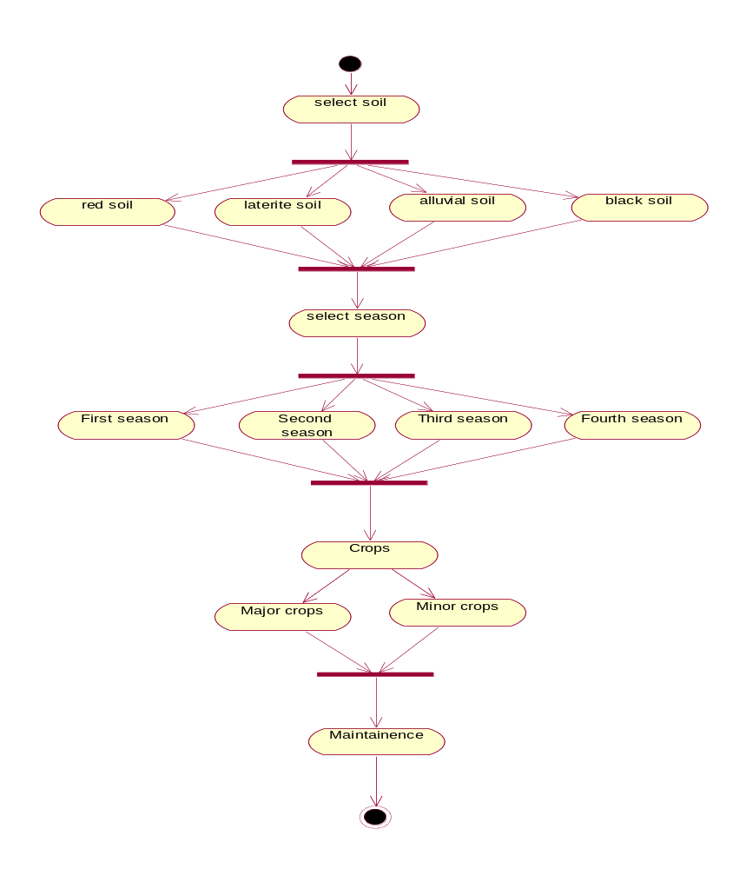
Fig 4.6 Activity Diagram
    - Component Diagram
Component diagrams fall under the category of an implementation diagram, a kind of diagram that models the implementation and deployment of the system. A Component Diagram, in particular, is used to describe the dependencies between various software components such as the dependency between executable files and source files. This information is similar to that within make files, which describe source code dependencies and can be used to properly compile an application.
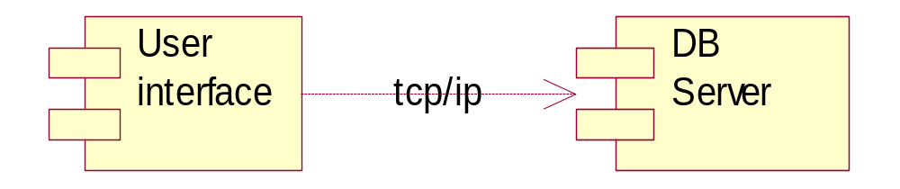
Fig 4.7 Component Diagram

- SOFTWARE AND HARDWARE REQUIREMENTS
  - Software Requirements
- Operating System : Windows XP and above
- Coding Language : Java
- Data Base : Microsoft Access 2003 and above
- IDE : Eclipse
  - Hardware Requirements
- Processor : Intel Pentium and above
- RAM : 512 MB
- Hard Disk : 40 GB

- CODING
  - Locating Database
JFileChooser has been used to locate and choose the database. It prompts the user to load the corresponding file which has been set. Here the JFileChooser has been set up with a FileFilter which filters out the files in the disk. The FileFilter has been set to select the database files. As Microsoft Access is the database used in this project, the extension of the database files are .mdb or .accdb. The FileFilter filters out all other files which do not end with these extensions and shows only the database files and directories. When the user selects the database file, the JFileChooser selects the database file and sends it to the main program for further execution. The coding of the JFileChooser and FileFilter are as follows:
JFileChooser jfc1=new JFileChooser ();
FileFilter filter=new FileFilter () {
public String getDescription() {
return "Select *.mdb or *.accdb files";
}
public boolean accept(File f) {
return f.getName().toLowerCase().endsWith(".mdb") | f.getName().toLowerCase().endsWith(".accdb") | f.isDirectory();
}};
jfc1.setFileFilter(filter);
int val;
while(true) {
val=jfc1.showOpenDialog(jfc1.getParent());
if(jfc1.getSelectedFile().toString().endsWith(".mdb")|jfc1.getSelectedFile().toString().endsWith(".accdb"))
break;
else
JOptionPane.showMessageDialog(null, "Please select a DataBase file (*.mdb or *.accdb)", "DataBase File Selection Error", 2);
}
String file = null;
if(val==JFileChooser.APPROVE_OPTION)
try {
file = jfc1.getSelectedFile().getCanonicalPath();
}
catch (IOException e1) {
e1.printStackTrace();
}
else if(val==JFileChooser.CANCEL_OPTION)
System.exit(0);
else if(val==JFileChooser.ERROR_OPTION)
System.exit(0);

  - Connecting to Database
When the required database file has been located and selected, connection to the database has to be made in order to access the database. To establish the connection, the JDBC-ODBC Driver has been used. This driver connects the Java program to the databases. After the driver is loaded, the Microsoft Access Driver has been passed over to the JDBC-ODBC Driver and a connection has been established with the database. After the connection is established, a Statement to execute SQL Queries has to be created. Then the statement has been passed over to the main modules for further processing. The coding of the connection to the database is as follows :
public void loadFile() {
try {
Class.forName("sun.jdbc.odbc.JdbcOdbcDriver");
}
catch (Exception e) {
e.printStackTrace();
}
String database="jdbc:odbc:Driver={Microsoft Access Driver (*.mdb, *.accdb)};DBQ="+file+";";
try {
con=DriverManager.getConnection(database,"","");
}
catch (Exception e) {
e.printStackTrace();
}
try {
stmt=con.createStatement();
}
catch (Exception e) {
e.printStackTrace();
}
mainScreenGUI();
}
  - Generating Report
The main screen consists of four buttons for the three modules and to exit from the program. These four buttons are been allocated appropriate functionality for processing of user input. The template of the main screen is as follows :
private void mainScreenGUI() {
soilsb = new JButton("Soil Selection");
seasonsb = new JButton("Season Selection");
cropsb = new JButton("Crop Selection");
soilsb.addActionListener(this);
seasonsb.addActionListener(this);
cropsb.addActionListener(this);
exit.addActionListener(this);
c.insets = new Insets(20, 20, 20, 20);
c.gridx=0; c.gridy=0;
p5.add(soilsb,c);
c.gridx=1;
p5.add(seasonsb,c);
c.gridx=0; c.gridy=1;
p5.add(cropsb,c);
c.gridx=1;
p5.add(exit,c);
f3.add(p5);
f3.setTitle("Method Selection - Crop Prediction");
f3.setVisible(true);
f3.pack();
f3.setLocationRelativeTo(null);
}
The first module in the project is the Soil Selection module. In this module, the user is prompted to select a Soil of his choice. Depending upon the choice of selection of the Soil, the user is then prompted to select the Crop that will be grown in the respective Soil. Following the Crop, another prompt to choose the sub Type of the Crop is prompted. The coding template of the Soil Selection module is as follows.
private void soilGUI() {
sll1 = new JLabel("Select Soil");
sll2 = new JLabel("Select Crop");
sll3 = new JLabel("Select Type");
c.insets = new Insets(20, 20, 20, 20);
c.gridx=0; c.gridy=0;
p8.add(sll1,c);
c.gridx=1;
String[] soils = {"Alluvial Soil","Black Soil","Black Sandy Soil","Clay","Drained Soil","Laterite Soil", "Loam","Moist Soil","Red Soil","Red Laterite Soil","Red Sandy Soil","Sandy Soil", "Soils with high fertility","All except Chavudu Soil","All Soils"};
jcbsl = new JComboBox<String>(soils);
p8.add(jcbsl,c);
c.gridx=0; c.gridy=1;
p8.add(sll2,c);
c.gridx=1;
jcb5 = new JComboBox<String>();
p8.add(jcb5,c);
c.gridx=0; c.gridy=2;
p8.add(sll3,c);
c.gridx=1;
jcb6 = new JComboBox<String>();
p8.add(jcb6,c);
p9.add(slb1);
p9.add(slb2);
p9.add(slb3);
f5.add(p8,BorderLayout.NORTH);
f5.add(p9,BorderLayout.SOUTH);
f5.setTitle("Soil Selection");
f5.setVisible(true);
f5.pack();
f5.setLocationRelativeTo(null);
}
The next module in the project is the Season Selection module. In this module, the user is prompted to select a Season of his choice. Depending upon the choice of selection of the Season, the user is then prompted to select the Crop that will be grown in the respective Season. Following the Crop, another prompt to choose the sub Type of the Crop is prompted. The coding template of the Season Selection module is as follows:
private void seasonGUI() {
ssl1 = new JLabel("Select Season");
ssl2 = new JLabel("Select Crop");
ssl3 = new JLabel("Select Type");
c.gridx=0; c.gridy=0;
c.insets = new Insets(20, 20, 20, 20);
p6.add(ssl1,c);
c.gridx=1;
String[] seasons = {"Kharif","Rabi","Summer","Early Kharif","Late Kharif","After Rice","All Seasons"};
jcbss = new JComboBox<String>(seasons);
p6.add(jcbss,c);
c.gridx=0; c.gridy=1;
p6.add(ssl2,c);
c.gridx=1;
jcb3 = new JComboBox<String>();
p6.add(jcb3,c);
c.gridx=0; c.gridy=2;
p6.add(ssl3,c);
c.gridx=1;
jcb4 = new JComboBox<String>();
p6.add(jcb4,c);
p7.add(ssb1);
p7.add(ssb2);
p7.add(ssb3);
f4.add(p6,BorderLayout.NORTH);
f4.add(p7,BorderLayout.SOUTH);
f4.setTitle("Season Selection");
f4.setVisible(true);
f4.pack();
f4.setLocationRelativeTo(null);
}
The last module in the project is the Crop Selection module. In this module, the user is prompted to select a Crop of his choice. Depending upon the choice of selection of the Crop, the user is then prompted to select the sub Type of the Crop. The coding template of the Crop Selection module is as follows :
private void cropGUI() {
f1.setTitle("Crop Selection");
c.insets = new Insets(20, 20, 20, 20);
c.gridx=0; c.gridy=0;
c.insets=new Insets(10, 10, 10, 10);
l1=new JLabel("Select crop");
p1.add(l1,c);
jcb1 = new JComboBox<String>(cbm1);
try {
dbmd = con.getMetaData();
rs = dbmd.getTables(null, null, "%", null);
while(rs.next()) {
sb = rs.getString(3);
if(!sb.startsWith("MSys"))
jcb1.addItem(sb);
}}catch (SQLException e) {
e.printStackTrace();
}
c.gridx=1;
p1.add(jcb1,c);
c.gridx=0; c.gridy=1;
l2=new JLabel("Types available");
l2.setVisible(false);
p1.add(l2,c);
c.gridx=1;
jcb2 = new JComboBox<String>(cbm2);
jcb2.setVisible(false);
p1.add(jcb2,c);
b1=new JButton("Next");
p3.add(b1,BorderLayout.SOUTH);
b1.setFocusable(false);
b1.addActionListener(this);
b2 = new JButton("Generate Report");
p3.add(b2,BorderLayout.SOUTH);
f1.setVisible(true);
f1.pack();
f1.setLocationRelativeTo(null);
}
The functionalities of various buttons used in the modules is as follows :
public void actionPerformed(ActionEvent e) {
source = (JButton) e.getSource();
if(source==character) {
f6.setVisible(true);
displayChar();
}
if(source==exit)
System.exit(0);
if(source==soilsb) {
f3.setVisible(false);
soilGUI();
}
if(source==cropsb) {
f3.setVisible(false);
cropGUI();
}
if(source==seasonsb) {
f3.setVisible(false);
seasonGUI();
}
if(source==b1) {
try {
rs = stmt.executeQuery("select Type from " + jcb1.getSelectedItem().toString());
jcb2.removeAllItems();
while(rs.next())
jcb2.addItem(rs.getString("Type"));
}
catch (SQLException e1) {
e1.printStackTrace();
}
l2.setVisible(true);
jcb2.setVisible(true);
f1.pack();
f1.setLocationRelativeTo(null);
b1.setVisible(false);
b2.setVisible(true);
}
if(source==b2)
display(3);
if(source==slb1) {
tables.removeAllElements();
try{
dbmd = con.getMetaData();
rs = dbmd.getTables(null, null, "%", null);
while(rs.next()) {
sb = rs.getString(3);
if(!sb.toString().startsWith("MSys"))
tables.addElement(sb);
}
for(int i=0; i<tables.size(); i++){
rs = stmt.executeQuery("Select * from " + tables.elementAt(i));
while(rs.next()){
flag = false;
sb = rs.getString("Soils");
if(sb.toString().equals("All"))
sb = "All Soils";
if(sb.toString().equals(jcbsl.getSelectedItem())){
jcb5.addItem(tables.elementAt(i));
break;
}
ss = sb.split("/");
for(j=0; j<ss.length; j++)
if(ss[j].equals(jcbsl.getSelectedItem())) {
jcb5.addItem(tables.elementAt(i));
flag = true;
break;
}
if(flag)
break;
}}
catch(SQLException e1) {
e1.printStackTrace();
}
sll2.setVisible(true);
jcb5.setVisible(true);
slb1.setVisible(false);
slb2.setVisible(true);
f5.pack();
f5.setLocationRelativeTo(null);
}
if(source==slb2){
tables.removeAllElements();
jcb6.removeAllItems();
try{
rs = stmt.executeQuery("select * from " + jcb5.getSelectedItem());
while(rs.next()){
sb = rs.getString("Soils");
String s3 = jcbsl.getSelectedItem().toString();
if(s3.equals("All Soils"))
s3 = "All";
if(sb.toString().equals(s3)){
jcb6.addItem(rs.getString("Type"));
continue;
}
ss = sb.split("/");
for(j=0; j<ss.length; j++)
if(ss[j].equals(s3)){
jcb6.addItem(rs.getString("Type"));
break;
}}}
catch (SQLException e1) {
e1.printStackTrace();
}
jcb6.setVisible(true);
sll3.setVisible(true);
slb2.setVisible(false);
slb3.setVisible(true);
f5.pack();
f5.setLocationRelativeTo(null);
}
if(source==slb3) {
f5.setVisible(false);
display(1);
}
if(source==ssb1) {
tables.removeAllElements();
try {
dbmd = con.getMetaData();
rs = dbmd.getTables(null, null, "%", null);
while(rs.next()) {
sb = rs.getString(3);
if(!sb.toString().startsWith("MSys"))
tables.addElement(sb);
}
jcb3.removeAllItems();
for(i=0; i<tables.size(); i++) {
rs = stmt.executeQuery("Select * from " + tables.elementAt(i));
while(rs.next()) {
flag = false;
map.clear();
for(j=1; j<=rs.getMetaData().getColumnCount(); j++)
map.put(rs.getMetaData().getColumnName(j), rs.getString(j));
if(!map.containsKey("Season"))
break;
sb = map.get("Season");
if(sb.toString().equals("All"))
sb = "All Seasons";
if(sb.toString().equals(jcbss.getSelectedItem())){
jcb3.addItem(tables.elementAt(i));
break;
}
ss = sb.split("[/,]");
for(j=0; j<ss.length; j++)
if(ss[j].equals(jcbss.getSelectedItem())) {
jcb3.addItem(tables.elementAt(i));
flag = true; break;
}
if(flag)
break;
}}}
catch (SQLException e1) {
e1.printStackTrace();
}
jcb3.setVisible(true);
ssl2.setVisible(true);
ssb1.setVisible(false);
ssb2.setVisible(true);
f4.pack();
f4.setLocationRelativeTo(null);
}
if(source==ssb2) {
tables.removeAllElements();
jcb4.removeAllItems();
try {
rs = stmt.executeQuery("select * from " + jcb3.getSelectedItem());
while(rs.next()) {
sb = rs.getString("Season");
String s3 = jcbss.getSelectedItem().toString();
if(s3.equals("All Seasons"))
s3 = "All";
if(sb.toString().equals(s3)) {
jcb4.addItem(rs.getString("Type"));
continue;
}
ss = sb.split("[/,]");
for(j=0; j<ss.length; j++)
if(ss[j].equals(s3))
jcb4.addItem(rs.getString("Type"));
}}
catch (SQLException e1) {
e1.printStackTrace();
}
jcb4.setVisible(true);
ssl3.setVisible(true);
ssb2.setVisible(false);
ssb3.setVisible(true);
f4.pack();
f4.setLocationRelativeTo(null);
}
if(source==ssb3)
{
f4.setVisible(false);
display(2);
}
}

  - Database Tables
Jonna
ID | Type | Season | Duration | Yield | Soils | Characteristics
3 | CSH-13 | Kharif/Rabi | 110-115 | 12-14 | Alluvial Soil
18 | CSH-13R | Rabi | 110-115 | 13-14 | Loam Soil
5 | CSH-14 | Kharif | 95-100 | 12-13 | Alluvial Soil
20 | CSH-15R | Rabi | 110-115 | 13-14 | Alluvial Soil
4 | CSH-16 | Kharif | 105-110 | 15-17 | Loam Soil
6 | CSH-18 | Kharif | 110-115 | 16-17 | Loam Soil
1 | CSH-5 | All | 105-110 | 14-16 | Loam Soil/Alluvial Soil
2 | CSH-9 | Kharif/Rabi | 105-110 | 16-18 | Alluvial Soil
14 | CSV -216R | Rabi | 110-115 | 12-14 | Alluvial Soil
19 | CSV-14R | Rabi | 115-120 | 10-12 | Loam Soil
8 | CSV-15 | Kharif | 110 | 10-12 | Alluvial Soil
17 | M35-1 | Rabi | 115-120 | 10-12 | Alluvial Soil
12 | N-13 | Rabi | 95-100 | 7-8 | Loam Soil/Alluvial Soil
13 | N-14 | Rabi | 110-115 | 10-12 | Loam Soil
9 | Nandyala Tella Jonna - 1 | Rabi | 105-110 | 10-12 | Alluvial Soil
10 | Nandyala Tella Jonna - 2 | Rabi | 95-100 | 12-14 | Loam Soil
11 | Nandyala Tella Jonna - 3 | Rabi | 100-105 | 12-14 | Loam Soil
16 | NTJ-4 | Rabi | 90-98 | 13-15 | Loam Soil
15 | Palem – 2 | Kharif | 105-110 | 11-12 | Alluvial Soil
7 | PSV-1 | Kharif/Rabi | 105-110 | 10-12 | Alluvial Soil
Table 6.1 - Database of Jonna
Sajja
ID | Type | Season | Duration | Yield | Soils | Characteristics
2 | ICMH-451 | Kharif/Summer | 85-90 | 10-12 | Sandy Soil
5 | ICMV-221 | Kharif/Summer | 85-90 | 8-10 | Sandy Soil
4 | ICTP-8203 | Kharif/Summer | 80-85 | 8-10 | Sandy Soil
3 | Mallikarjuna | Kharif/Rabi | 80-85 | 8-10 | Sandy Soil
1 | WCC75 | Kharif/Summer | 85-90 | 8-10 | Sandy Soil
Table 6.2 - Database of Sajja
The Type field indicates the type of the Crop. The Season field indicates the seasons in which the crop type can be grown. The Duration field indicates the duration of the crop in days. The Yield field indicates how many Quintals of the crop can be produced from one acre of farming. The Soils field indicates the soils in which the crop can be grown. The Characteristics field indicates the characteristics of the crop. The Seed % indicates the percentage of seed from a plant of the oil crop. The Oil % indicates the percentage of oil from a seed of the oil crop.

- TESTING
Testing is a process, which reveals errors in the program. It is the major quality measure employed during software development. During testing, the program is executed with a set of test cases and the output of the program for the test cases is evaluated to determine if the program is performing as it is expected to perform.
  - Testing Approach
Test objectives
- All field entries must work properly.
- Pages must be activated from the identified link.
- The entry screen, messages and responses must not be delayed.
Features to be tested
- Verify that the entries are of the correct format
- No duplicate entries should be allowed
  - Testing Strategies
In order to make sure that the system does not have errors, different levels of testing strategies are applied at differing phases of software development.

Black Box Testing

Black Box Testing is testing the software without any knowledge of the inner workings, structure or language of the module being tested. Black box tests, as most other kinds of tests, must be written from a definitive source document, such as specification or requirements document, such as specification or requirements document. It is a testing in which the software under test is treated, as a black box .you cannot “see” into it. The test provides inputs and responds to outputs without considering how the software works.

White Box Testing
White Box Testing is a testing in which in which the software tester has knowledge of the inner workings, structure and language of the software, or at least its purpose. It is purpose. It is used to test areas that cannot be reached from a black box level.

Unit Testing
Unit testing is usually conducted as part of a combined code and unit test phase of the software lifecycle, although it is not uncommon for coding and unit testing to be conducted as two distinct phases.
- System Testing
The purpose of testing is to discover errors. Testing is the process of trying to discover every conceivable fault or weakness in a work product. It provides a way to check the functionality of components, sub assemblies, assemblies and/or a finished product It is the process of exercising software with the intent of ensuring that the Software system meets its requirements and user expectations and does not fail in an unacceptable manner. There are various types of test. Each test type addresses a specific testing requirement.
- Integration Testing
Software integration testing is the incremental integration testing of two or more integrated software components on a single platform to produce failures caused by interface defects.
The task of the integration test is to check that components or software applications, e.g. components in a software system or – one step up – software applications at the company level – interact without error.

Test Results
All the test cases mentioned above passed successfully. No defects encountered.
- Functional Testing
Functional tests provide systematic demonstrations that functions tested are available as specified by the business and technical requirements, system documentation, and user manuals.
Functional testing is centered on the following items:
Valid Input : identified classes of valid input must be accepted
Invalid Input : identified classes of invalid input must be rejected
Functions : identified functions must be exercised
Output : identified classes of application outputs must be exercised
System / Procedure : interfacing systems or procedures must be invoked
  - Test Cases
A test case is a set of input data and expected results that exercises a component with purpose of causing failures and detecting faults. Organization and preparation of functional tests is focused on requirements, key functions, or special test cases. In addition, systematic coverage pertaining to identify Business process flows; data fields, predefined processes, and successive processes must be considered for testing. Before functional testing is complete, additional tests are identified and the effective value of current tests is determined.

- OUTPUT SCREENS
  - Snapshots
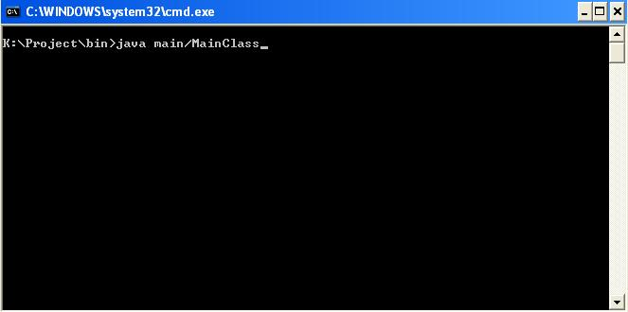
Screen 8.1 Running the Project
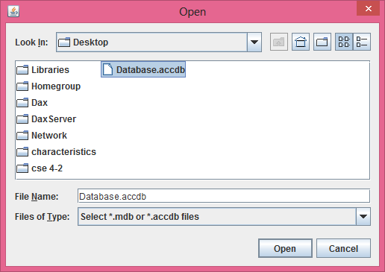
Screen 8.2 Load Database File
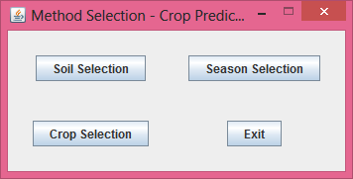
Screen 8.3 Main Screen
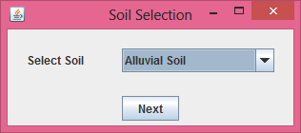
Screen 8.4 Select Soil
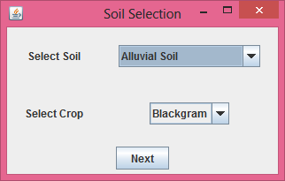
Screen 8.5 Select Crop
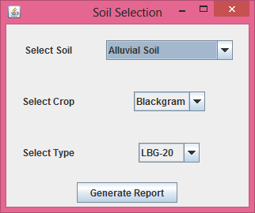
Screen 8.6 Select Crop Type
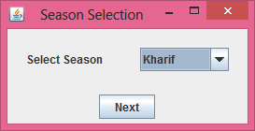
Screen 8.7 Select Season
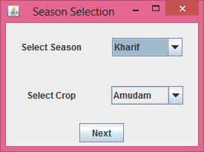
Screen 8.8 Select Crop
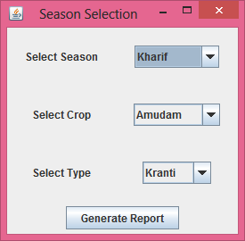
Screen 8.9 Select Crop Type
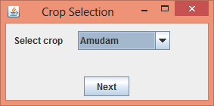
Screen 8.10 Select Crop
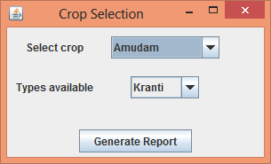
Screen 8.11 Select Crop Type
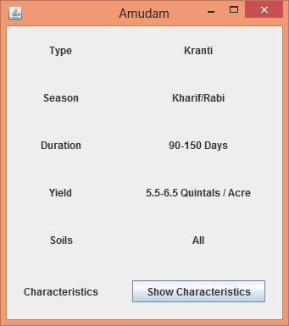
Screen 8.12 Report on selected Crop
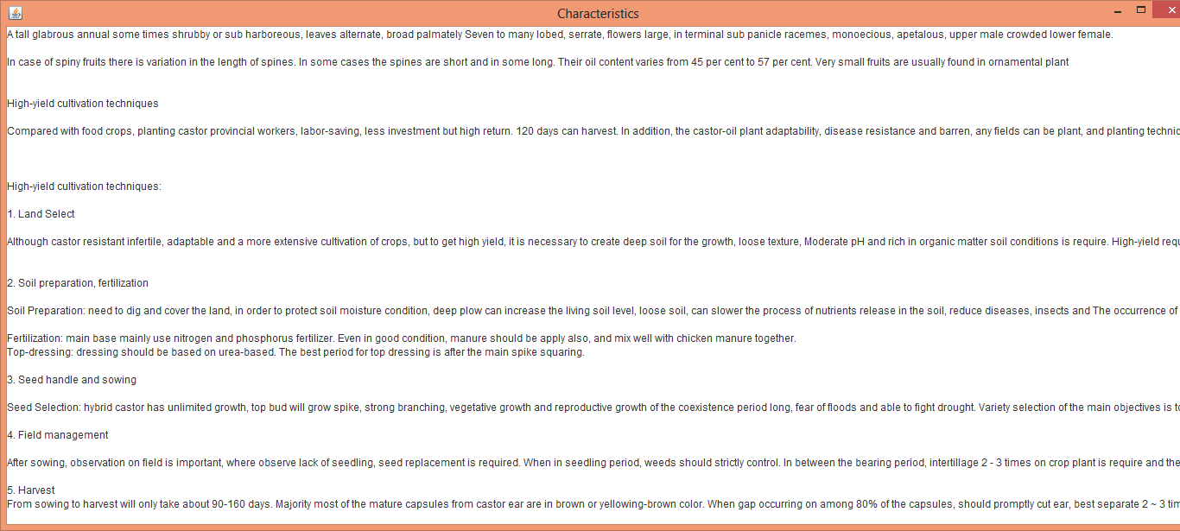
Screen 8.13 Characteristics of selected Crop

CONCLUSION
This system has been developed incorporating all the requirements. The computerization of the critical data and information regarding the crops and helps Farmers by facilitating ease of gaining knowledge on the crops, both old and new has been done. We found this project to be far more difficult than we ever anticipated. We have developed the groundwork for the application with great potential.

FURTHER ENHANCEMENTS
The database of the Crops can be further extended so that the project covers entire area of the State. It can also be extended with Telugu Fonts so that the farmers who don’t know English would get benefitted as equally as those who know English.
We strongly recommend using this project to increase the awareness about the new and unknown crops among the farmers community. This would be beneficiary to them as they would come to know about the types of crops that can be cultivated in their region. This would also help in an efficient usage of the land during the Crop Holiday season.

BIBLIOGRAPHY
[1] Avi Silberschatz, Henry F. Korth, S. Sudarshan, Database System Concepts, Tata McGraw-Hill Publications.
[2] Dr. Gogineni Veerendhranath, Vyavasaya Panchangam 2008-2009, Agricultural Information and Publications Centre, Acharya N.G. Ranga Agricultural University.
[3] Dr. K.T. Chandy, Classification of Crops, Booklet No. 227 - Agricultural Extension: & Education: AEES-2.
[4] Herbert Schildt, The Complete Reference JAVA2, 5th edition, Tata McGraw Hill.
[5] S. Veenadhari, Dr. Bharat Misra, Dr. CD Singh, Data Mining Techniques for Predicting Crop Productivity – A Review Article, IJCST Vol 2, Issue 1, March 2011.
[6] www.wikipedia.org, Wikipedia.
[7] www.java-forums.org, Java Forums.
[8] www.indianingredients.blogspot.in, Overview on Indian Ingredients.
[9] www.agri.ap.nic.in, Department of Agriculture, Andhra Pradesh.
[10] www.agricoop.nic.in

